ACUTE CHEST SYNDROME IN SCD IN PREGNANCY OR EVOLUTION OF VIRAL PNEUMONIA – A DIAGNOSTIC DILEMMA IN COVID-19 PANDEMIC

Dr. Deepthi Leelia Betzy.R, PG Resident,

Dr. Pushpawati Thakur, Associate Professor,

Dr. Sarita Rajbhar, Assistant Professor,

Department of Obstetrics and Gynecology, All India Institute of Medical Sciences (C.G)

**INTRODUCTION:-**

Sickle cell disease (SCD), as an Autosomal Recessive hemoglobinopathy, is a multiorgan disease characterised by vaso-occlusive crises and chronic anaemia1. It is one of the most common genetic disorders globally with over 300,000 children born with the condition each year2. Acute chest syndrome (ACS) is a leading cause of death for patients with SCD. It is defined as a new radiodensity on chest radiograph accompanied by fever and/or respiratory symptoms. Viral infections are a common trigger for ACS in paediatric sickle cell patients. The incidence of viral infections causing ACS in adults is less than 10%3. Pregnancies with sickle cell disease are associated with an almost eightfold increased pulmonary complications4.

The lack of comprehensive data on pulmonary complications for pregnant women with SCD and the scattered case reports suggesting viral infection could trigger ACS in adults have led to difficulties in clinical care pathways, which becomes significant in the COVID-19 Pandemic, especially for high prevalence region like Chattisgarh.

**CASE REPORT:-**

A 34 year old woman, third gravida with 2 abortions at 34 weeks of gestation with known case of Sickle Cell Disease (SCD) presented to AIIMS Emergency ward with complaints of sudden onset of shortness of breath for 1 day with a history of pain in arms and legs 10 days back. She was apparently well 10 days back after which she developed severe pain in arms and legs and lab values were suggestive of severe anaemia. Her pain relieved after initial supportive therapy and 3 pints of blood transfusion at outside hospital. There was no fever or cough. She was diagnosed with SCD at 10 years of age and her prior history was notable for episodes of painful crisis requiring multiple blood transfusions, IV Ig and Hydroxyurea therapy. At the presentation, dyspnoea and hypoxia (SpO2 94%) were observed and was corrected with 5 litres/min of supplemental oxygen (continued intermittently for next 5 days). A chest X-ray was done at admission which showed ill-defined heterogenous opacifications (possibly consolidation) and a SARS-COV-2 PCR nasopharyngeal swab testing was positive. She was started on an empirical course of Azithromycin and Ceftriaxone. She was also managed with Inj. LMWH and Inj. Dexamethasone in view of moderate COVID-19 infection.

However, on hospital day 10, she developed new onset of cough and fever with worsening of dyspnoea (SpO2 94%) correcting with 4 litres/min of supplemental oxygen. Her lab investigations began to show evidence of haemolysis with a decrease in haemoglobin (8.4 gm%), increase in total bilirubin 2.25 mg/dL (unconjugated 1.24 mg/dL); and an increase in LDH (895 U/L). There was also evidence of an acute inflammatory response marked by elevated CRP (274 mg/L), elevated IL-6 (102.6 pg/ml), raised ferritin (>1650 ng/ml) and D-Dimer (1154 ng/mL). A repeat Chest X-ray was done on day 10, which was suggestive of an increase in heterogenous opacity and haziness in mid and lower lobes possibly due to consolidation. There was also a marked increase in Total counts (33.0 x 103/ microlitre) with a neutrophilic shift (92.8%) and a growth of E.coli on blood culture and urine culture. A baseline ECG was done which showed sinus tachycardia.

Although these lab values were inconclusive and can be seen overlapping with conditions like vaso-occlusive crisis, thromboembolic event, acute chest syndrome and ongoing pneumonia, her clinical presentation with subsequent Chest X-ray features, leucocytosis and a positive blood culture were consistent with ACS and ongoing pneumonia. Hence, a working diagnosis of Sickle Cell Disease (SCD) with Acute Chest Syndrome (ACS) complicated with COVID (viral) pneumonia and secondary bacterial infection was made and in view of her worsening respiratory and clinical status, she was started on Hydroxychloroquine, Piperacillin- Tazobactam, and one pint blood transfusion. She was also started on Labetalol for mild pre-eclampsia (new onset HTN and proteinuria).

Meanwhile, on day 12, she went into spontaneous preterm labour and an emergency LSCS was done in view of fetal distress. Post-operatively, she was continued on intermittent supplemental oxygen, started on Amoxy-Clav and one pint blood transfusion. On day 16, her symptoms relieved, her room air oxygen saturation improved to 98% with an improvement in lab values (decrease in total counts and decrease in haemolysis). Her subsequent SARS-COV-2 PCR nasopharyngeal swab testing on day 19 was negative and her follow up Chest X-ray showed resolution of findings except for subtle haziness in lower zone. Baby’s COVID status was also negative. Patient is currently under follow-up.

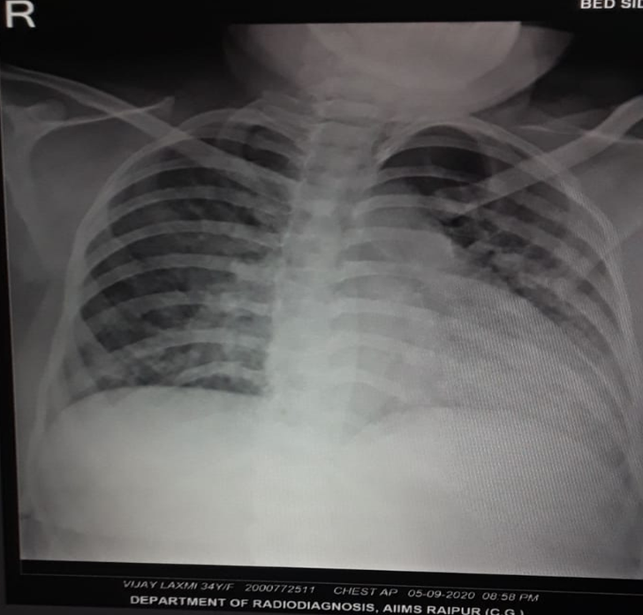 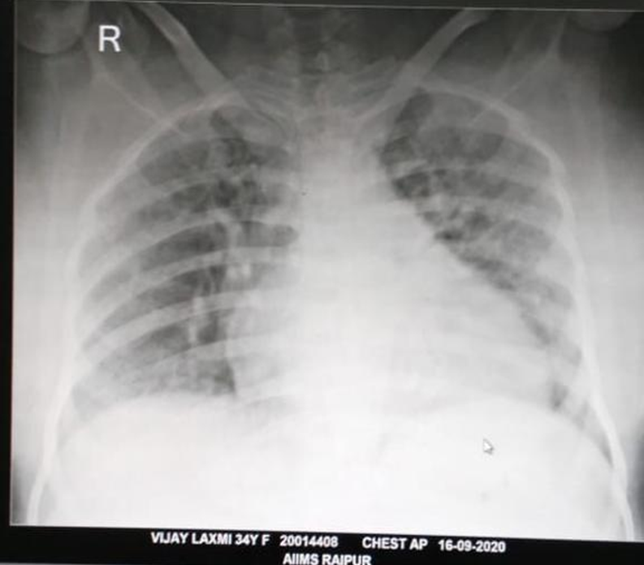 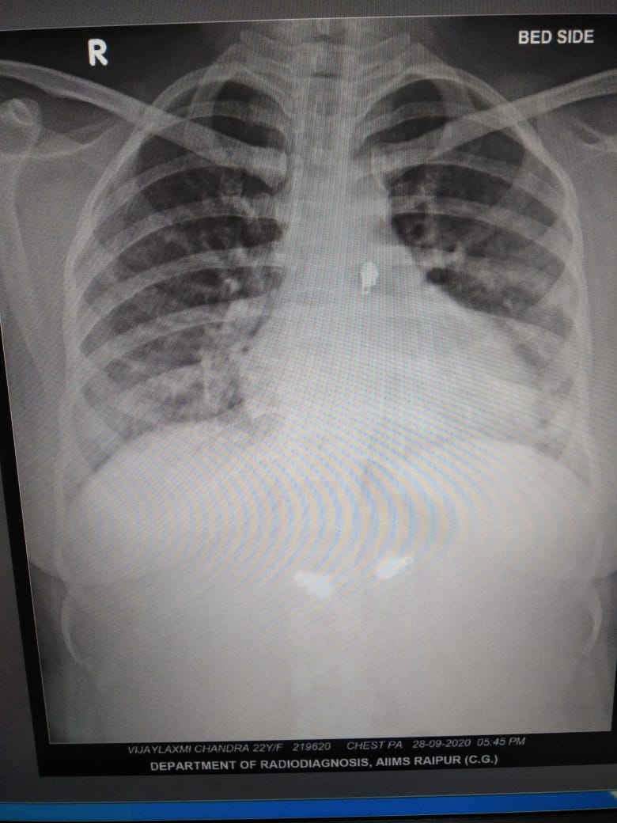

**RADIOLOGICAL IMAGES- Progression of Acute Chest Syndrome/ COVID-19 pneumonia and response to treatment. A). Chest X-ray on day 1 with ill-defined heterogenous opacification with air bronchogram noted in left mid and lower zones. B). Chest X-ray on day 10 showing increase in heterogenous opacity and haziness in left mid and lower zones possibly due to consolidation. C). Chest X-ray on day 22 with resolution of findings except for subtle haziness in left lower zone.**

**DISCUSSION:-**

Viral infections are a common cause of Acute Chest Syndrome (ACS) in paediatric sickle cell patients. However, the incidence of viral infections inciting ACS in adult sickle cell patients has been reported to be seen in less than 10% of cases3,5. The World Health Organization (WHO) recently declared SARS‐CoV‐2 (COVID-19) infection a pandemic6. Viral pandemics are of particular risk to vulnerable SCD patients, however, data from previous pandemics is both limited and conflicting. On literature search, no evidence about SCD patients and 2002 SARS-COV outbreak exist and sparse evidence about SCD patients and 2009 H1N1 influenza pandemic exists7. As COVID-19 is an emerging disease, there is scarcity of data on how the pandemic may complicate SCD patients. In SCD, COVID‐19 can potentially cause severe (pulmonary) complications, either by directly causing severe pneumonia or by triggering a Vaso-occlusive crisis and/or Acute chest syndrome (ACS). There are very few literature on pulmonary infection by COVID-19 in SCD, considering its short time of history. In a recent meta-analysis report, it was observed that the prevalence of ACS is 6.46% for women with SCD during pregnancy4. Another recent systematic review on maternal and perinatal outcomes in COVID-19 showed that although there were some cases of severe maternal and perinatal morbidity, majority had a favourable outcome8.

The ACS episodes in adults with SCD are often clearly preceded by a prodrome of vaso-occlusive pain episode like chest pain, arm and leg pain. Upto one-fifth of adults with a history of ACS can develop a rapidly progressive ACS characterised by respiratory failure and multi-organ failure9.

There is a significant overlap between clinical presentation of ACS with pulmonary thromboembolism, pneumonia or even acute coronary syndrome. Although a patient with pulmonary embolus may present with shortness of breath and chest pain similar to ACS, pulmonary emboli will typically have a chest radiograph negative for new radiodensities9,10. Also, a vaso-occlusive pain episode is more suggestive of ACS than a pulmonary embolus. In this patient, pulmonary embolus was less likely suspected as there was typical chest radiographic features of consolidation. Although pulmonary embolus was less likely suspected, she was started on thromboprophylaxis with low molecular weight heparin (LMWH), as the risk of embolus formation is still high in patients with SCD and ACS.

There are limited data regarding features that suggest a myocardial damage in individuals with SCD. However, an initial baseline evaluation has to be done in any SCD patient presenting with acute chest pain to rule out myocardial infarction. In our case scenario, a baseline ECG was done which showed sinus tachycardia without ischaemic changes.

It is also understood that ACS is a separate clinical entity to pneumonia with a different pathophysiology. However, clinically the differentiation of ACS from pneumonia can be difficult and challenging. Therefore, empiric antibiotic therapy should be considered in treatment apart from the initial measures for ACS9,11. This patient presented with a history of vaso-occlusive pain episode relieved after blood transfusions and initial supportive therapy. There were also multiple overlapping features of both ACS and COVID pneumonia in this patient like elevation of LDH, elevation of D-Dimer and non-specific chest radiograph findings. Hence, an initial working diagnosis of SCD with ACS, progressing to pneumonia was made. She was managed with 4 L/ min of supplemental oxygen therapy, Dexamethasone, blood transfusion, low molecular weight heparin (in view of both COVID infection and SCD thromboprophylaxis) and also antibiotic coverage. She was also managed with Hydroxychloroquine (as per the revised ICMR protocol for moderate COVID-19 infection). A significant improvement in the clinical status was observed in this patient after initiation of blood transfusion and other supportive therapy. There was also no significant abnormality or COVID-19 infection noted in the baby.

**CONCLUSION:-**

Based on the literature evidence of higher likelihood of ACS in SCD patients during the previous H1N1 outbreak, there is a possibility that SCD patients are at higher risk of ACS from COVID-19 as well. Although viral infections causing ACS in adult SCD patients are lesser, the risk of such complications should be anticipated, especially in those with a prior history of vaso-occlusive pain crisis or pulmonary comorbidities. Case reports with vaso-occlusion and/or ACS caused by SARS-CoV-2 demonstrate that consideration of this infection, with rapid diagnosis and intervention, can result in excellent recovery12. Also, in moderate COVID infection, an early and excellent recovery can be seen in patients treated with Dexamethasone and LMWH with or without Antiviral drugs. Hence, hospitalized sickle cell patients should be closely monitored for development of complications and if they occur, early diagnosis and treatment should be initiated to reduce significant maternal and perinatal morbidity and mortality.

**REFERENCES:-**

1. Weatherall DJ. Abc of clinical haematology. The hereditary anaemias. BMJ 1997;314:492
2. Howard J, Oteng-N tim E. The obstetric management of sickle cell disease. Best Pract Res Clin Obstet Gynaecol 2012;26:25–36.
3. Vichinsky EP, Neumayr LD, Earles AN, et al. Causes and outcomes of the acute chest syndrome in sickle cell disease. National Acute Chest Syndrome Study Group. N Engl J Med. 2000;342(25):1855- 1865.
4. S. Inparaj, M. Buckingham, L. Oakley, P.T. Seed, S. Lucas, E. Oteng-Ntim. Pulmonary complications for women with sickle cell disease in pregnancy: systematic review and meta-analysis.
5. Zhou F, Yu T, Du R, et al. Clinical course and risk factors for mortality of adult inpatients with COVID‐19 in Wuhan, China: a retrospective cohort study. *Lancet*. 2020; **395**: 1054‐ 1062.
6. R.E. Ware, M. de Montalembert, L. Tshilolo, M.R. Abboud. Sickle cell disease. Lancet, 390 (2017), pp. 311-323
7. Beerkens F, John M, Puliafito B, Corbett V, Edwards C, Tremblay D. COVID-19 pneumonia as a cause of acute chest syndrome in an adult sickle cell patient. Am J Hematol. 2020, <http://dx.doi.org/10.1002/ajh.25809>. Epub ahead of print.
8. M. Zaigham, O. Andersson. Maternal and perinatal outcomes with COVID-19: a systematic review of 108 pregnancies. Acta Obstet Gynecol Scand, 7 (2020)
9. Joshua J Field, MDMichael R DeBaun, MD, MPH. Acute chest syndrome in adults with sickle cell disease. UpToDate. Last updated June 08, 2020. <https://www.uptodate.com/contents/acute-chest-syndrome-in-adults-with-sickle-cell-disease#H292564704>
10. Feldman L, Gross R, Garon J, et al. Sickle cell patient with an acute chest syndrome and a negative chest X-ray: potential role of the ventilation and perfusion (V/Q) lung scan. Am J Hematol 2003; 74:214.
11. Hussain FA, Njoku FU, Saraf SL, Molokie RE, Gordeuk VR, Han J. COVID-19 infection in patients with sickle cell disease. Br J Haematol. 2020;189(5):851–2.
12. Nur E, Gaartman AE, van Tuijn CF, Tang MW, Biemond BJ. Vaso-occlusive crisis and acute chest syndrome in sickle cell disease due to 2019 novel coronavirus disease (COVID-19). Am J Hematol. 2020;95(6):725–6.