TITLE-“Obesity rising trend and associated endometrial changes and postoperative complications”

AUTHOR- Dr Purnima Singh, Dr(Prof. )Sarita Agrawal

INSTITUTION- All India Institute Of Medical Sciences, Raipur

ABSTRACT

Objective- Management of low grade intraepithelial neoplasia and postoperative wound infection in obese patients with medical comorbidities

Background- The prevalence of obesity is increasing in India and worldwide. Obesity is a recognized risk factor for endometrial intraepithelial neoplasias(EINs) and endometrial malignancy, and postoperative wound infection and thus, placement of an abdominal incision can be challenging in these patients. Certain medical conditions like hypertension, diabetes mellitus and hypothyroidism can also cause endometrial changes and affect wound healing postoperatively.

Case- 52 years, P2L2A1, known case of hypertension, diabetes mellitus, hypothyroidism and controlled asthma, with postmenopausal bleeding diagnosed as Endometrial intraepithelial neoplasia-low grade underwent extrafascial hysterectomy on 10/12/2019 under general anesthesia. Intraoperative, there was difficulty due to abdominal obesity. Postoperatively patient developed wound infection and purulent discharge on day 8. Patient was managed conservatively with wound dressing, antibiotics according to wound swab culture and sensitivity report and vigorous management of blood sugars and other medical conditions, and patient underwent secondary resuturing on 29/12/2019.

Outcome-Patient underwent secondary resuturing on 29/12/2019 after postoperative wound infection following extrafascial hysterectomy on 10/12/2019 for low grade EIN.

INTRODUCTION-

Obesity is a growing and significant healthcare issue (1-4). In 1910, Dr. Kelly described obesity, stating “to be a storehouse for useless adipose tissue and to carry this handicap around, openly displayed wherever one goes, is one of the most distressing of life's minor ailments (5).” While current viewpoints may be less extreme, obesity continues to carry a social stigma and is increasingly present in our society (2,4,6,7). Obesity is responsible for more than 25 percent of the increase in healthcare costs over the past 15 years (2,4).

Endometrial hyperplasia is of clinical significance because it is often a precursor lesion to adenocarcinoma of the endometrium(8,9). The precursor lesion of type I endometrioid adenocarcinoma is endometrial intraepithelial neoplasia. Estrogenic stimulation of the endometrium, unopposed by progestins, causes proliferative glandular epithelial changes. This finding, due to prolonged hormonal exposure, is biologically distinct from true precancerous lesions and true neoplasia. Making the distinction between hyperplasia and true precancerous lesion or true neoplasia has significant clinical effect because their differing cancer risks must be matched with an appropriate intervention to avoid undertreatment or overtreatment. As gynecologists we should be aware of the two nomenclature schemas and that the endometrial intraepithelial neoplasia schema seems to be preferable to the WHO94 schema. Pathologic diagnosis of premalignant lesions should use criteria and terminology that clearly distinguish between clinicopathologic entities that are managed differently. At present, the endometrial intraepithelial neoplasia schema is tailored most closely to this objective, incorporating modified pathologic criteria based upon evidence that has become available since the creation of the more widely used WHO94 schema.

In the endometrial intraepithelial neoplasia schema, endometrial precancer is termed “endometrial intraepithelial neoplasia”(10,11). Pathologic criteria were used to develop three disease categories:1)benign (benign endometrial hyperplasia), 2)premalignant(endometrial intraepithelial neoplasia ), and 3) malignant(endometrial adenocarcinoma, endometroid type, well differentiated). By applying the endometrial intraepithelial neoplasia schema to routinely obtained endometrial tissues, pathologists present the clinician with a disease- specific classification that inform treatment decisions. Diagnosis using the endometrial intraepithelial neoplasia schema has been confirmed as prognostic in several retrospective studies and one prospective study(12-14). Two of these studies also suggest that interobserver reproducibility using the endometrial intraepithelial neoplasia schema can be greater than with the WHO94 schema(12,14)

Obesity with other medical comorbidities is a known risk factor for delayed wound healing and postoperative wound infection.The vascular insufficiencies and altered population of immune mediators present may lengthen the inflammatory stage of wound healing, as well as leaving obese individuals more susceptible to infections. Wound healing is also delayed as a result of macronutrient and micronutrient deficiencies in obese individuals. Without the proper cofactors and enzymes, the process of wound healing is compromised, as well as the integrity of the wound. Nutritional supplements can be given to obese patients preoperatively as a possible solution to decrease wound complications.

Pitkin first observed increased operative and postoperative risks when abdominal hysterectomy is performed on obese patients(15). He noted significantly more postoperative fever in the obese patients versus nonobese (59% versus 36%) and a significant difference in wound complications for obese patients over nonobese (29% wound complication rate versus 4%). Krebs and Helmkamp reported a wound infection rate of 24% in massively obese patients when a periumbilical transverse incision was used(16). Because muscle cutting is needed for this transverse incision, entry time can be lengthy and relatively hemorrhagic. If any transverse incision is chosen for obese patients, it should be far removed from the anaerobic moist environment of the subpannicular fold.

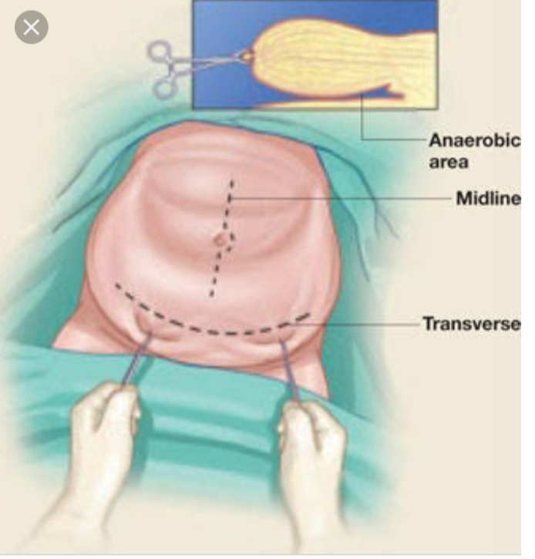

Fig.2- Midline incision in obese patient. The panniculus is retracted inferiorly, and the incision avoids the moist anaerobic enviroment

CASE-

A 52 year old Mrs Temin Chandrakar came with complaint of bleeding per vaginum for 3 days in September 2019 after 7 years of attaining menopause in 2012. Patient had spotting only not associated with passage of clots or pain. She underwent diagnostic hysteroscopy with endometrial biopsy with endocervical curettage with VIA & VILI guided biopsy on 24th september2019. She had no similar episodes in past, no history of vomiting or abdominal distension or discomfort, no history of loss of appetite or weight,& no history of drug intake for hormonal replacement therapy.

Menstrual and obstetric history- She attained menopause in 2012,her previous cycles where regular, 3-5 days/30 days, no history suggestive of menorrhagia or dysmenorrheal.

P2L2A2- both term vaginal delivery, her last child birth was 28 years back, she breast fed her children for less than 3 months postpartum.

She is a known case of diabetes mellitus on Tab Metformin SR 500 mg TDS, hypertension on Tab Telmisartan 40 mg 1 tab od, Tab Atorvastatin 10 mg 1 tab od HS, hypothyroidism on Tab Thyrox 25 ug OD ES and bronchial asthma- well controlled.

Her mother was diagnosed with carcinoma endometrium after having hysterectomy done.

On examination- Her general condition was fair. She was obese with a BMI of 35 kg/m2. Vitals- stable with cardiovascular and respiratory system examination- within normal limits.

Per abdomen- abdominal obesity present,

Per speculum- cervix pinpoint, no bleeding or discharge seen from the cervix or vagina.

Per vaginum- cervix pulled up and firm, uterus- retroverted 6 weeks size firm mobile, bilateral fornices free and non tender.

DH- EB+VIA+ VILI+ CERVICAL BIOPSY(24/10/2019)-

VIA –TZ TPPE III, acetowhite area at 6”o”clock ,VILI – Posterior lip negative -cervical biopsy taken

Hysteroscopic finding: 0.5\*0.5 cm endocervical polyp ,Calcific deposit in endocervical canal,Endometrium polypoidal with calcific deposit,Endometrium highly vascular,1\*1 cm endometrial polypectomy done

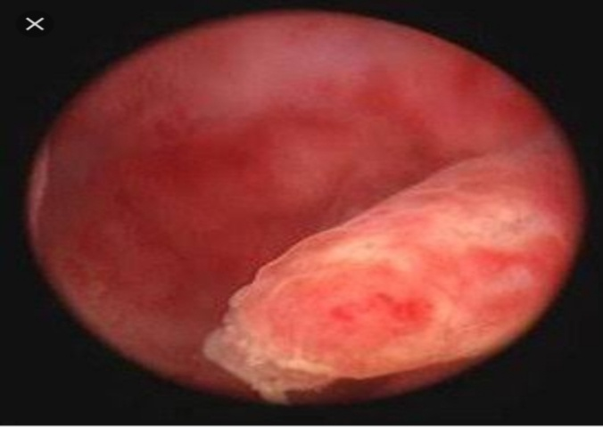

Fig.2. Hysteroscopic picture of endometrial polyp

HPE(24/10/2019)- Mild cervicitis, Endometrial polyp with features of low grade endometrial intraepithelial neoplasia , Endometrial tissue- benign polyp with focal squamous metaplasia

HPV (17 /09/2019) – High risk HPV -16 positive

PAP smear(17/09/2019)- Negative for intraepithelial lesion or malignancy

IMAGING STUDIES- USG:02/11/2019 - Liver Grade 1 fatty liver,Spleen and kidneys are normal, no effusion or ascites ,Pelvis: Uterus 68\*33\*48 mm,Endometrial cavity empty,ET: 12.8 mm,B/L Adnexa free. POD free.Visualized bowel loops appear normal, no definite evidence of wall thickening or mass lesions.

MRI (contrast)20/11/2019- Uterus is postmenopausal in size. Endometrium 3.1 mm. No overt discrete mass lesion visulised ,Myometrium show normal signal intensity,however possibility of superficial endocervical /endometrial infiltrative process not ruled out .

Patient underwent extrafascial hysterectomy on 10/12/2019 under general anesthesia. Intraoperative, there was difficulty due to abdominal obesity. Postoperatively patient developed wound infection and purulent discharge on day 8. Patient was managed conservatively with wound dressing, antibiotics according to wound swab culture and sensitivity report and vigorous management of blood sugars and other medical conditions, and patient underwent secondary resuturing on 29/12/2019.Her histopathology report of surgical specimen was suggestive of low grade EIN with no involvement of lymph nodes. No lymphatic or vascular spread.

Conclusion- The prevalence of obesity is increasing, obesity with other medical co morbidities (metabolic syndrome) is a known risk factor for EINs and endometrial cancer, and postoperative wound infections, which are also in rising trends, although timely recognition and management can decrease both morbidity and mortality.

REFERENCES-

1. Cottam DR, Mattar SG, Barinas-Mitchell E, et al. The chronic inflammatory hypothesis for the morbidity associated with morbid obesity: implications and effect of weight loss. *Obesity Surgery*. 2004;14(5):589–600. [[PubMed](https://www.ncbi.nlm.nih.gov/pubmed/15186624" \t "pmc_ext)] [[Google Scholar](https://scholar.google.com/scholar_lookup?journal=Obesity+Surgery&title=The+chronic+inflammatory+hypothesis+for+the+morbidity+associated+with+morbid+obesity:+implications+and+effect+of+weight+loss&author=DR+Cottam&author=SG+Mattar&author=E+Barinas-Mitchell&volume=14&issue=5&publication_year=2004&pages=589-600&pmid=15186624&)]

2. Encinosa WE, Bernard DM, Chen C-C, Steiner CA. Healthcare utilization and outcomes after bariatric surgery. *Medical Care*. 2006;44(8):706–712. [[PubMed](https://www.ncbi.nlm.nih.gov/pubmed/16862031" \t "pmc_ext)] [[Google Scholar](https://scholar.google.com/scholar_lookup?journal=Medical+Care&title=Healthcare+utilization+and+outcomes+after+bariatric+surgery&author=WE+Encinosa&author=DM+Bernard&author=C-C+Chen&author=CA+Steiner&volume=44&issue=8&publication_year=2006&pages=706-712&pmid=16862031&)]

3. Camden SG, Gates J. Obesity: changing the face of geriatric care. *Ostomy Wound Management*. 2006;52(10):36–44. [[PubMed](https://www.ncbi.nlm.nih.gov/pubmed/17041253" \t "pmc_ext)] [[Google Scholar](https://scholar.google.com/scholar_lookup?journal=Ostomy+Wound+Management&title=Obesity:+changing+the+face+of+geriatric+care&author=SG+Camden&author=J+Gates&volume=52&issue=10&publication_year=2006&pages=36-44&)]

4. Thorpe KE, Florence CS, Howard DH, Joski P. The impact of obesity on rising medical spending. *Health Affairs*. 2004;(Web Exclusives):480–486. [[PubMed](https://www.ncbi.nlm.nih.gov/pubmed/15496437" \t "pmc_ext)] [[Google Scholar](https://scholar.google.com/scholar_lookup?journal=Health+Affairs&title=The+impact+of+obesity+on+rising+medical+spending&author=KE+Thorpe&author=CS+Florence&author=DH+Howard&author=P+Joski&issue=Web+Exclusives&publication_year=2004&pages=480-486&)]

5. Kelly HA. Excision of the fat of the abdominal wall lipectomy. *Surgery, Gynecology & Obstetrics*. 1910;10, article 229 [[Google Scholar](https://scholar.google.com/scholar_lookup?journal=Surgery,+Gynecology+&+Obstetrics&title=Excision+of+the+fat+of+the+abdominal+wall+lipectomy&author=HA+Kelly&volume=10,+article+229&publication_year=1910&)]

6. Wilson JA, Clark JJ. Obesity: impediment to postsurgical wound healing. *Advances in Skin & Wound Care*. 2004;17(8):426–435. [[PubMed](https://www.ncbi.nlm.nih.gov/pubmed/15492679" \t "pmc_ext)] [[Google Scholar](https://scholar.google.com/scholar_lookup?journal=Advances+in+Skin+&+Wound+Care&title=Obesity:+impediment+to+postsurgical+wound+healing&author=JA+Wilson&author=JJ+Clark&volume=17&issue=8&publication_year=2004&pages=426-435&pmid=15492679&)]

7. Schauer PR, Schirmer BD. *Schwartz’s Principles of Surgery*. 8th edition. New York, NY, USA: McGraw Hill Companies; 2005. The surgical management of obesity; pp. 997–1016. [[Google Scholar](https://scholar.google.com/scholar_lookup?title=Schwartz%E2%80%99s+Principles+of+Surgery&author=PR+Schauer&author=BD+Schirmer&publication_year=2005&)]

8. Sherman ME. Theories of endometrial carcinogenesis: a multidisciplinary approach. Mod Pathol 2000;13:295-308.

9.Silverberg SG, Kurman RJ, Nogales F, Mutter GL, Kubikhuch RA, Tavassoli FA, Devilee P, editors. Pathology and genetics of tumours of the breast and female genital organs. World Health Organization classification of tumours. Lyon (France):IARC Press;2003. P. 221-32

10.Mutter GI, Baak JP, Crum CP, Richart RM, Ferenczy A, Faquin WC, Endometrial precancer diagnosis by histopathology, clonal analysis, and computerized morphometry. J Pathol 2000;190;462-9

11.Mutter GI, Endometrial intraepithelial neoplasia(EIN):will it bringe order to chaos? The endometrial collaborative group. Gynecol oncol 2000;76:287-90

12. Baak JP, Mutter GI, Robboy S, van Diest Pj, Uyterlinde AM OrboA, et al. the molecular genetics and morphometry based endometrial intraepithelial neoplasia classification system predicts disease progression in endometrial hyperplasia more accurately than the 1994 World Health Organization classification system. Cancer2005;103:2304-12

13.Mutter GI, Kauderer J, Baak JP, Alberts D. Biopsy histomorphometry predicts uterine myoinvasion by endometrial carcinoma: a gynecologic Oncology Group study. Gynecologic Oncology Group . Hum Pathol 2008;39:866-74

14.Hecht JL., Ince TA, Baak JP, Baker HE, Ogden MW, Mutter GI., Prediction of endometrial carcinoma by subjective endometrial intraepthelial neoplasia diagnosis. Mod Pathol 2005;18:324-30

15. Pitkin RM. Abdominal hysterectomy in obese women. Surg Gynecol Obstet 1976;142:532.

16. Krebs HB, Helmkamp F. Transverse periumbilical incision in the massively obese patient. Obstet Gynecol 1984;63:241.

17. Yvonne N. Pierpont, Trish Phuong Dinh, R. Emerick Salas, Erika L. Johnson, Terry G. Wright, Martin C. Robson, Wyatt G. Payne: [Obesity and Surgical Wound Healing: A Current Review](https://www.ncbi.nlm.nih.gov/pmc/articles/PMC3950544/), ISRN Obes. 2014; 2014: 638936. Published online 2014 Feb 20. doi: 10.1155/2014/638936