“STAGE BASED INTEGRATED MANAGEMENT USING BARCELONA PROTOCOL VERSUS CONVENTIONAL MANAGEMENT OF FETAL GROWTH RESTRICTION AND PERINATAL OUTCOME: A RANDOMIZED CONTROLLED TRIAL”

DR. NAGMA SHEIKH  
PROF. DR. SARITA AGRAWAL

DEPARTMENT OF OBSTETRICS AND GYNECOLOGY

ALL INDIA INSTITUTE OF MEDICAL SCIENCES, RAIPUR, C.G.

**INTRODUCTION**

Fetal growth restriction (FGR) refers to the failure of a fetus in meeting its biological growth potential due to impaired placental function.1 FGR as a term is often interchangeably used with SGA (small for gestational age). FGR fetuses in contrast to SGA are pathologically small and are at a risk of adverse perinatal outcomes.2,3 FGR infants demonstrate early evidence of cardiac, vascular, pulmonary, neurological and other deficits, which can lead to long durations in the Neonatal Intensive Care Unit (NICU) and long term health problems.4,5 Furthermore, growth restriction increases the risk of cardiovascular disease in adult life.6

Early detection of FGR can substantially reduce the risk of stillbirth.7 Nutritional and dietary supplemental strategies for the prevention of FGR are not effective and are not recommended.8 Thus, the mainstay of management of FGR remains monitoring of fetal well-being and optimizing the timing of delivery. FGR is among the obstetrical entities with the greatest variation in clinical practice with respect to monitoring and recommended gestational age at delivery.9

There is a lack of consistent classification and characterization regarding the severity of FGR. Hence, a protocol that integrates the best available evidence can help reducing clinical practice variation. One such protocol10 is proposed by the Barcelona Center of Maternal-Fetal Medicine that classifies stages of fetal deterioration and establishes follow-up intervals and optimal delivery timings. It aims to combine existing evidence on various methods of monitoring fetal well-being to establish risks of fetal injury or death, and to balance them against the risks of prematurity if fetus is delivered. It facilitates decision-making and minimizing variability in the clinical management.

In order to guide and establish standard of care for FGR/SGA fetuses in terms of timing and mode of delivery, we propose a well-designed randomized controlled clinical trial that tested the efficacy of the Barcelona protocol of FGR staging and management and evaluated its effectiveness in reducing perinatal mortality and morbidity.

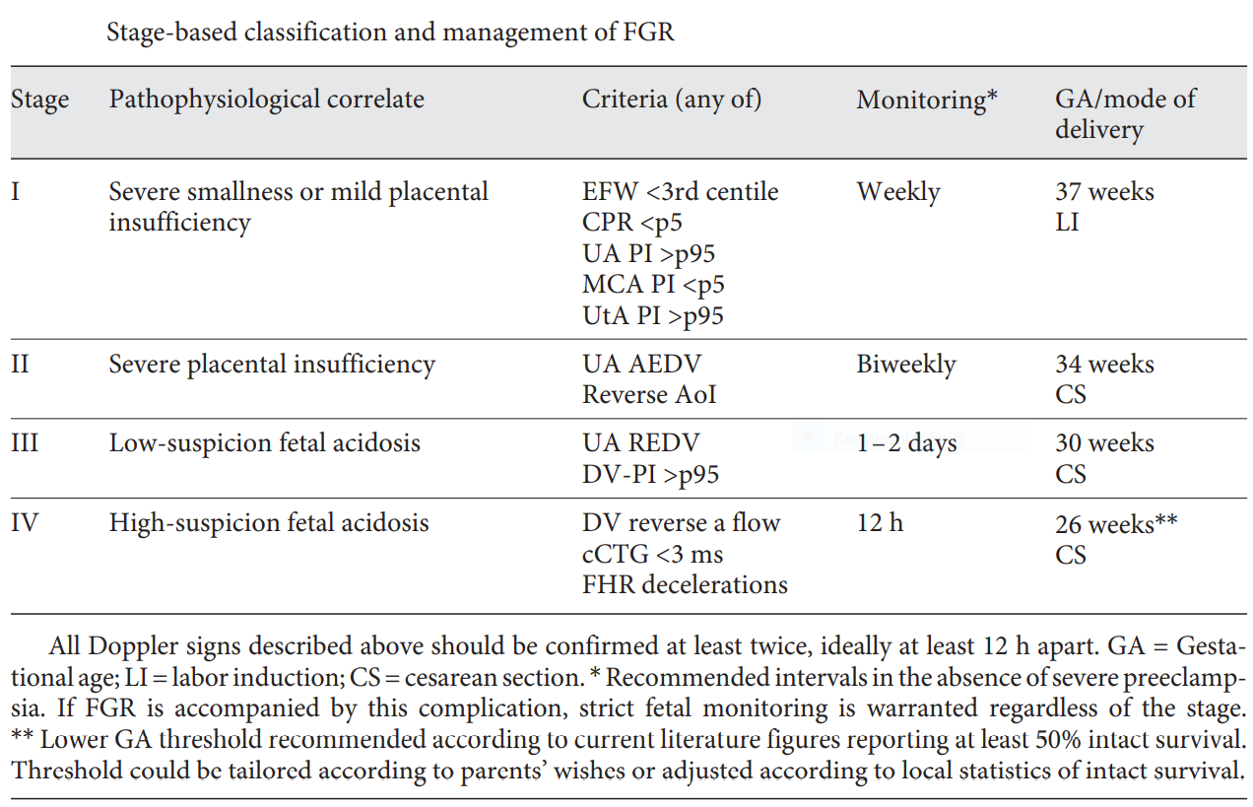

**SGA**: Fortnightly Doppler and growth assessment is safe and constitutes standard practice. Labor induction should be recommended at 40 weeks.

**Stage I FGR** [severe smallness or mild placental insufficiency]: Either Uterine artery, UA or MCA Doppler, or the CPR are abnormal. Available evidence suggests a low risk of fetal deterioration before term. Labor induction beyond 37 weeks is acceptable, but the risk of intrapartum fetal distress is increased.

**Stage II FGR** [severe placental insufficiency]: This stage is defined by UA AEDV (and also probably by reverse AoI). Delivery should be recommended after 34 weeks. The risk of emergent caesarean section at labor induction exceeds 50%, and, therefore, elective caesarean section is a reasonable option. Monitoring twice a week is recommended.

**Stage III FGR** [advanced fetal deterioration, low-suspicion signs of fetal acidosis]: The stage is defined by reverse diastolic flow in the UA (REDV) or DV-PI>95th centile. There is an association with a higher risk of stillbirth and poorer neurological outcome. However, since signs suggesting a very high risk of stillbirth within days are not present yet, it seems reasonable to delay elective delivery to reduce as possible the effects of severe prematurity. We suggest delivery should be recommended by cesarean section after 30 weeks. Monitoring every 24-48 is recommended.

**Stage IV FGR** [high-suspicion of fetal acidosis and high risk of fetal death]: There are spontaneous FHR decelerations, reduced short term variability (<3ms) in the cCTG, or reverse atrial flow in the DV Doppler. Deliver after 26 weeks by cesarean section at a tertiary care center under steroid treatment for lung maturation (and prophylaxis of cerebral palsy with magnesium sulphate). Intact survival exceeds 50% only after 26-28 weeks, and before this threshold parents should be counseled by multidisciplinary teams. Monitoring every 12-24 hours until is recommended.

**RESEARCH QUESTION**

Is stage based integrated management of fetal growth restriction using Barcelona protocol more effective than conventional antenatal management in terms of perinatal outcome?

**OBJECTIVES**

1. To determine the perinatal outcome using integrated management of FGR using Barcelona protocol.

To compare the perinatal outcome of FGR by stage based integrated management using Barcelona protocol with conventional antenatal management.

**MATERIAL AND METHODS**

Randomized Controlled Trial

Department of Obstetrics & Gynecology, AIIMS Raipur

All women with singleton pregnancy at or after 26 weeks of gestation with FGR.

Patients with clinical diagnosis and USG suggestive of FGR satisfying the inclusion and exclusion criteria.

**FETAL OUTCOME**

* Gestational age at delivery
* APGAR Score – 1min, 5min
* Birth weight
* Resuscitation needed or not
* Need of NICU admission
* Reason for NICU admission
* Neonatal complications, if any
* Duration of NICU admission
* Follow up after 7 days and 1 month

**MATERNAL OUTCOME**

Maternal complications, if any

* Antepartum
* Intrapartum
* Postpartum

**Dependent variables.**

1. Post induction Bishop’s score at 6th hour, 12th hour, 24th hour from drug administration
2. Improvement in Bishop’s score at 6th , 12th and 24th hour from drug administration
3. Successful cervical ripening
4. Need for additional ripening agent
5. Need for augmentation of labour
6. Induction to delivery interval
7. Mode of delivery
8. Indication of operative delivery
9. Maternal complications- Hypertonus uterine contractions, any other.
10. Fetal complication- meconium stained liquor, fetal distress, APGAR score at birth and one minute after birth, need for neonatal resuscitation, NICU admission – if yes then indication and duration of admission.

DELIVERY (VAGINAL/ CAESAREAN)

Group-A

Management as per

Barcelona tool (iFetal Calculator)

Group-B

Management as per

Conventional management

Group-C

Women will be given cerviprime gel 0.5 mg intracervical, and repeat gel after 6 hours if Bishop’s score < 6 but maximum of 2 doses will be given and monitored for 24 hours.

RANDOMIZATION

History and examination

Noting all previous investigations including USG

* Exclusion criteria –

1. Multifetal gestation
2. Intrauterine death
3. Fetal congenital anomalies
4. Patient presenting in labour

* Inclusion criteria –

1. Live fetus
2. With no diagnosed congenital anomalies
3. Consenting to participate in the study

**OBSERVATIONS**

Out of 30 women, 15 were randomized into group A and 15 women into group B.

Out of 15 in each group, 12 women were FGR and 3 women were SGA.

|  |  |  |  |
| --- | --- | --- | --- |
| **S. NO.** | **AGE (YEARS)** | **GROUP-A n(%)** | **GROUP-B n(%)** |
| 1 | >18-<25 | 4 | 1 |
| 2 | >25-<30 | 7 | 7 |
| 3 | >30-<35 | 4 | 6 |
| 4 | >35 |  | 1 |
|  | TOTAL | 15 | 15 |

Table 1. Distribution of women according to age

|  |  |  |  |
| --- | --- | --- | --- |
| **S. NO.** | **GRAVIDA** | **GROUP-A n(%)** | **GROUP-B n(%)** |
| 1 | 1 | 7 | 11 |
| 2 | 2 | 5 | 2 |
| 3 | 3 | 2 |  |
| 4 | 4 & ABOVE | 1 | 2 |
|  | TOTAL | 15 | 15 |

Table 2. Distribution of women according to gravidity

|  |  |  |  |
| --- | --- | --- | --- |
| **S. NO.** | **STAGE OF FGR/ SGA** | **GROUP-A n(%)** | **GROUP-B n(%)** |
| 1 | SGA | 3 | 3 |
| 2 | STAGE 1 FGR | 12 | 12 |
| 3 | STAGE 2 FGR |  |  |
| 4 | STAGE 3 FGR |  |  |
| 5 | STAGE 4 FGR |  |  |
|  | TOTAL | 15 | 15 |

Table 3. Distribution of women according to SGA/FGR

Table 4. Distribution of women according to mode of delivery.

|  |  |  |  |  |  |  |  |  |  |  |
| --- | --- | --- | --- | --- | --- | --- | --- | --- | --- | --- |
| **MODE** | **SGA** | | **STAGE 1 FGR** | | **STAGE 2 FGR** | | **STAGE 3 FGR** | | **STAGE 4 FGR** | |
| GROUP-A | GROUP-B | GROUP-A | GROUP-B | GROUP-A | GROUP-B | GROUP-A | GROUP-B | GROUP-A | GROUP-B |
| SPONTANEOUS VAGINAL DELIVERY | 2 |  | 2 | 1 |  |  |  |  |  |  |
| INDUCED VAGINAL DELIVERY | 1 | 2 | 2 | 2 |  |  |  |  |  |  |
| ELECTIVE CASESAREAN |  | 1 | 4 | 8 |  |  |  |  |  |  |
| EMERGENCY CAESAREAN |  |  | 4 | 1 |  |  |  |  |  |  |
| TOTAL | 3 | 3 | 12 | 12 |  |  |  |  |  |  |

|  |  |  |  |  |  |  |  |  |  |  |  |
| --- | --- | --- | --- | --- | --- | --- | --- | --- | --- | --- | --- |
| **S. NO.** | **GA AT DELIVERY** | **SGA** | | **STAGE 1 FGR** | | **STAGE 2 FGR** | | **STAGE 3 FGR** | | **STAGE 4 FGR** | |
| GROUP-A | GROUP-B | GROUP-A | GROUP-B | GROUP-A | GROUP-B | GROUP-A | GROUP-B | STUDY GROUP | CONTROL GROUP |
|  | 32-33+6 |  |  |  | 2 |  |  |  |  |  |  |
|  | 34-35+6 |  |  |  | 3 |  |  |  |  |  |  |
|  | 36-37+6 |  | 1 | 3 | 6 |  |  |  |  |  |  |
|  | 38-39+6 |  | 2 | 7 | 1 |  |  |  |  |  |  |
|  | >40 | 3 |  | 2 |  |  |  |  |  |  |  |
|  | TOTAL | 3 | 3 | 12 | 12 |  |  |  |  |  |  |

Table 5. Distribution of women according to gestational age at delivery.

|  |  |  |  |
| --- | --- | --- | --- |
| **S. NO.** | **BIRTHWEIGHT (Kg)** | **GROUP-A n(%)** | **GROUP-B n(%)** |
| 1 | <2.5 | 7 | 11 |
| 2 | >2.5 | 8 | 4 |
|  | TOTAL | 15 | 15 |

Table 6. Distribution of neonates according to birthweight.

|  |  |  |  |
| --- | --- | --- | --- |
| **MEAN APGAR AT 1 MINUTE** | | **MEAN APGAR AT 5 MINUTES** | |
| GROUP-A | GROUP-B | GROUP-A | GROUP-B |
| 7.8 | 8.6 | 7.9 | 7.0 |

Table 7. Distribution of neonates according to APGAR score.

|  |  |  |  |
| --- | --- | --- | --- |
| **S. NO.** | **REASON FOR NICU ADMISSION** | **GROUP-A** | **GROUP-B** |
|  | RESPIRATORY DISTRESS | 0 | 2 |
|  | HYPERBILIRUBINEMIA | 0 | 2 |
|  | SEPTICEMIA | 0 | 1 |

Table 8. Distribution of babies according to NICU admission.

|  |  |  |  |
| --- | --- | --- | --- |
| **S. NO.** | **COMPLICATIONS** | **GROUP-A n(%)** | **GROUP-B n(%)** |
| 1 | RESPIRATORY DISTRESS | 0 | 1 |
| 6 | SEPTICEMIA | 0 | 1 |
|  | TOTAL | 0 | 2 |

Table 9. Distribution of neonates according to follow-up at 7th day of life.

**RESULTS**

3 Women in each group were SGA and 12 were stage-1 FGR.

Most women with FGR (50%) were of the age group 25-30 years of age.

Most women (60%) were primigravidas.

In women managed with the Barcelona protocol, 7 babies (46%) had a vaginal delivery while 5 women (33%) with the conventional management had vaginal delivery.

Mean age at delivery in SGA:40+1weeks in group-A versus 38weeks in group-B.

In Stage-1 FGR, it was 38+6weeks in group-A versus 36+4weeks in group-B.

Birth weight:<1500 grams- 2 neonates in conventionally managed group, none in Barcelona group;

1500-2499 grams: 8 neonates in Barcelona group, 10 in conventionally managed group;

2500-2999 grams: 6 neonates in Barcelona group and 3 in conventional group;

>3000 grams: 1 neonate in Barcelona group, none in conventional group.

Mean APGAR scores at 1 minute of life was 7.8 in the Barcelona group versus 7.0 in the conventional group. APGAR at 5 minutes of life was 8.6 in the Barcelona group and 7.9 in the conventional group.

5 babies managed conventionally needed admission in the NICU due to - respiratory distress (2), hyperbilirubinemia (2), septicemia (1). None of the Barcelona group babies had these complications.

Follow-up at 7th day of life- 2 babies in the conventional management group had complications- respiratory distress (1) and septicemia (1).

**CONCLUSION-**

Management with the Barcelona protocol resulted in more vaginal deliveries than conventional management. The rate of Caesarean deliveries was lesser (26%) versus the conventional management group (33%). The mean gestational age at delivery in SGA fetuses was 15 days longer in the group managed using the Barcelona protocol. In FGR fetuses, it was 16 days longer in the Barcelona group. Difference in the birth weights was insignificant (p=0.136). Better 1-minute and 5-minute APGAR scores (p=0.03 and 0.012 respectively) are seen in the Barcelona group. Moreover, it results in a standardized, uniform management that aids to minimize variability in the clinical practice.

**REFERENCES**

1. Gordijn SJ, Beune IM, Thilaganathan B, et al. Consensus definition of fetal growth restriction: a Delphi procedure. *Ultrasound Obstet Gynecol*. 2016;48(3):333-339. doi:10.1002/uog.15884
2. Figueras, Francesc & Gratacos, Eduard. (2016). The integrated approach to fetal growth restriction. Best Practice & Research Clinical Obstetrics & Gynaecology. 38. 10.1016/j.bpobgyn.2016.10.006.
3. Ananth CV, Friedman AM. Ischemic placental disease and risks of perinatal mortality and morbidity and neurodevelopmental outcomes. *Semin Perinatol.* 2014;38(3):151-158. Doi:10.1053/j.semperi.2014.03.007
4. Malhotra A, Allison BJ, Castillo-Melendez M, Jenkin G, Polglase GR, Miller SL. Neonatal Morbidities of Fetal Growth Restriction: Pathophysiology and Impact. *Front Endocrinol (Lausanne)*. 2019;10:55. Published 2019 Feb 7. doi:10.3389/fendo.2019.00055
5. Miller SL, Huppi PS, Mallard C. The consequences of fetal growth restriction on brain structure and neurodevelopmental outcome. *J Physiol*. 2016;594(4):807-823. doi:10.1113/JP271402
6. Sasi A, Abraham V, Davies-Tuck M, et al. Impact of intrauterine growth restriction on preterm lung disease. *Acta Paediatr*. 2015;104(12):e552-e556. doi:10.1111/ apa.13220
7. Menendez-Castro C, Rascher W, Hartner A. Intrauterine growth restriction - impact on cardiovascular diseases later in life. *Mol Cell Pediatr*. 2018;5(1):4. Published 2018 Mar 20. doi:10.1186/s40348-018-0082-5
8. ACOG Practice Bulletin No. 204. Obstetrics & Gynecology. 2019;133(2):e97-e109.
9. Figueras, Francesc & Gratacós, Eduard. (2014). Stage-based approach to the management of fetal growth restriction. Prenatal diagnosis. 34. 10.1002/pd.4412
10. Figueras F, Gratacós E. Update on the diagnosis and classification of fetal growth restriction and proposal of a stage-based management protocol. *Fetal Diagn Ther*. 2014;36(2):86‐98. doi:10.1159/000357592