TITLE: SUCCESSFUL PREGNANCY OUTCOME IN A CASE OF TAKAYUSU’S ARTERITIS WITH RECURRENT PREGNANCY LOSS

AUTHORS:

Dr Loukya Kodumuri, PG Resident, Department of OBGY, AIIMS RAIPUR

Dr Sarita Rajbhar, Assistant professor, Department of OBGY, AIIMS RAIPUR

Dr Pushpawati, Associate professor, Department of OBGY, AIIMS RAIPUR

Dr Sarita Agrawal, Professor and HOD, Department of OBGY, AIIMS RAIPUR

INTRODUCTION: Takayasu’s arteritis(TA), also known as Pulseless disease/ Aortoarteritis /“young female arteritis,” is a rare chronic inflammatory progressive large vessel vasculitis (LVV) of unknown etiology causing narrowing, occlusion, and aneurysms of systemic and pulmonary arteries, especially the aorta and its branches, afflicting women of childbearing age[1].

It is an uncommon disease with estimated annual incidence rate of 1.2-2.6 per million. It was first described by the Japanese ophthalmologists Mikito Takayasu and Onishi [2]. Its incidence is reported to be 13 cases per million population [3]. It is predominantly seen in the women of Asian origin [4]. It leads to narrowing, occlusion, and aneurysms of systemic and pulmonary arteries in the body, affecting primarily the aorta and its branches.

Pregnancy as such has no effect on the evolution of the disease, however, the mean age of TA presentation is typically in the second and third decades of life[5].Thus, such patients warrant special attention during the peripartum period owing to the likelihood of development of complications such as hypertension, multiple organ dysfunction, and stenosis hindering regional blood flow leading to restricted intrauterine fetal growth and low birth weight in babies [7-9].

Delay in diagnosis is quite common, so patients often conceive without prior knowledge of having TA, or having initiated specific treatment against it[6].

Ideal management for pregnant patients with this disease still poses a stringent challenge, especially in the light of movement towards multicentric LVV research across the world, coupled with the recent availability of levitating pool of targeted drugs.

An interdisciplinary collaboration of obstetricians, cardiologists, rheumatologists, and neurologists is often necessitated for an optimal maternal and fetal prognosis.Taking into consideration the small-scale researches in literature so far on active TA in pregnancy, especially in LMIC countries, here a case is described and literature reviewed to enlighten the obstetricians on fetomaternal outcome and management of this infrequent, but not uncommon clinical entity encountered nowadays[1].

CASE PRESENTATION: A 33yrs old third gravida, conceived after ovulation induction, was admitted in the hospital as pregnancy with chronic hypertension and low lying placenta at 23 weeks gestation.

She had history of one still birth at 7 months and one spontaneous abortion, for which she had no hospital visit. She had no significant past and family history.

Her physical examination revealed a difference of 40 mm Hg in Systolic BP between the arms and was subjected for further evaluation. No hypertensive retinopathy changes on fundus examination.

After discussing with the nephrologist and physician, a probable diagnosis of Takayasu’s arteritis was made and she was started on LMWH and aspirin.

Her immunological workup revealed P-ANCA and C-ANCA negative. APLA profile was negative. ANA profile was negative.

USG KUB raised a suspicion of Renal artery stenosis and arterial Doppler of bilateral upper limbs and lower limbs raised a suspicion of possibility of arteritis due to biphasic spectral waveform in left upper limb and bilateral lower limbs.

ECG and 2D ECHO revealed NO significant abnormality.

She was followed up and she had an elective cesarean section as there was late onset Foetal growth restriction at 37 weeks 5 days gestation and delivered a term alive female baby of 1.73kg on 22 June 2021.

She is doing well postoperatively and her BP is maintained well on Anti Hypertensives. Baby was shifted to NICU in view of prematurity and was shifted to mother’s side after 7 days.

CT angiography done postoperatively, revealed near complete occluding thrombus in left subclavian artery and irregular circumferential plaques along the abdominal aorta resulting in diffuse segmental narrowing, more marked in the infrarenal segment s/o Midaortic syndrome secondary to burnt out granulomatous aorto-arteritis (Takayasu arteritis).

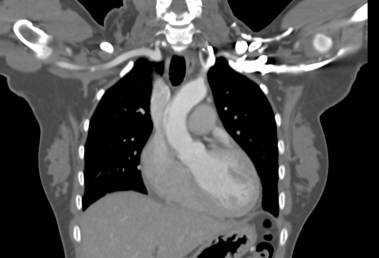

Figure 2: coronal reformatted maximum intensity projection of the chest demonstrating near completely occluding thrombus in the left subclavian artery with narrowed caliber at the origin.

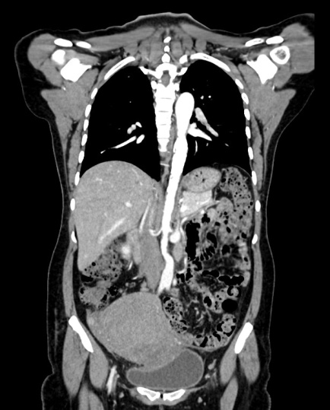

Figure 4 :Oblique projections of 3D shaded surface display images of the aortic tree from the ascending aorta to the aortic bifurcation demonstrating narrowing at the origin of left subclavian artery and narrowing of the infrarenal.

Figure 3: Coronal maximum intensity projection image demonstrating the irregular circumferential plaque in the infrarenal abdominal aorta with narrowed caliber of the same.

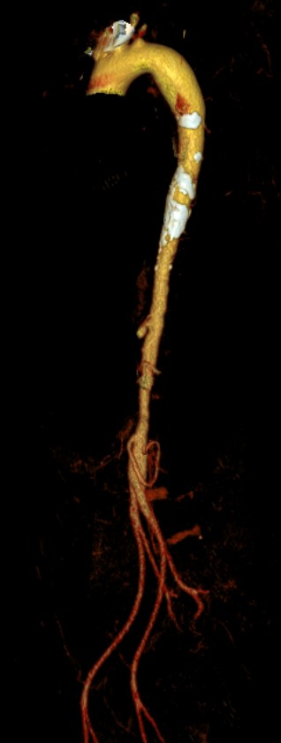

As per EULAR (European League Against Rheumatism) consensus criteria, the American college of Rheumatology classification criteria for Takayasu arteritis and Ishikawa diagnostic criteria, the diagnosis of Takayasu's arteritis was confirmed as the patient had angiographic abnormalities and hypertension[10-11].

She was started on prednisolone and atorvastatin in addition to aspirin and LMWH. She was discharged on POD - 10 with advice on regular follow-up and explaining the complications.

DISCUSSION: Women account for 80- 90% of takayasu arteritis and the age of onset is usually between 10 and 40 years. The disease has a worldwide distribution with greatest prevalence being in Asia. The initial description was given by Dr. M Takayasu. The etiology and pathogenesis are still unkown. Autoimmunity, sex hormones,and genetic( HLA BW52) factors have often been hypothesized as plausible factors causing it. This is a systemic disease with generalized as well as vascular symptoms. Life threatening complications include congestive cardiac failure, cerebrovasular events, myocardial infarction, hemoptysis, aneurysmal rupture and renal failure[6]. In addition, pregnancy doesn’t interfere with the disease progression of TA.Blood pressure monitoring can be challenging in patients with pulseless peripheral arteries. In most cases described in literature, and in the present case, it was possible to use the noninvasive technique[12]. If there is a large difference in blood pressure in upper and lower limbs, one must encourage recording it in both limbs. To evaluate limb perfusion a good alternative is to assess blood pressure in one limb and oximetry in the other. Antihypertensive drugs and antiplatelets can be started as per need, as was in the present case.  However, BP control is of paramount importance as any increase might rupture an aneurysm, induce hypotension and lead to cerebral ischemia in the mother.Various types of TA have been acknowledged in the past: type I (disease embroiling aortic arch and its branches), type II (lesions constrained to descending thoracic aorta and abdominal aorta), type III (patients with characteristics of types I and II), type IV (involvement of pulmonary artery), and type V (combined features of types IIb and IV)[13].Our patient come under Type -3.

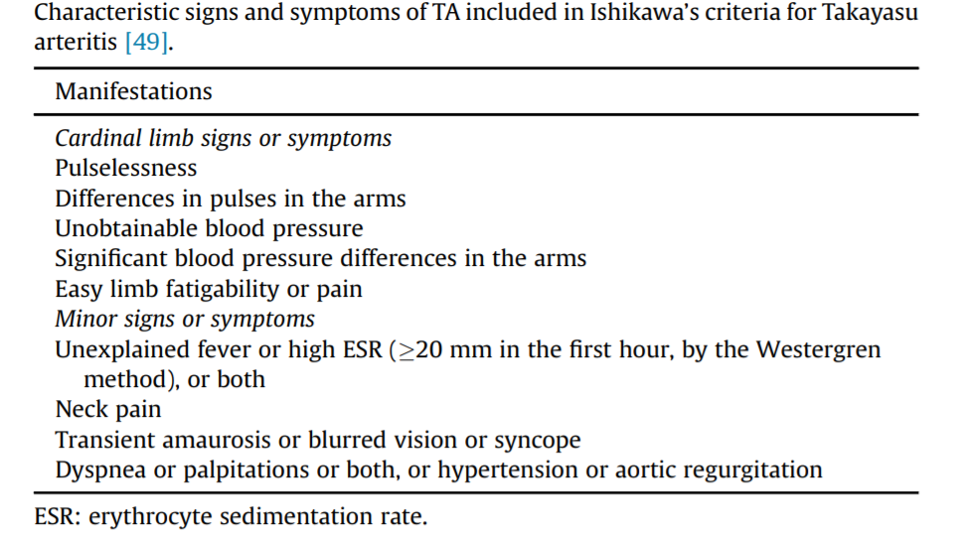[11]

The management includes a team of obstetrician, anesthetist, rheumatologist, and neonatologist. Patient should be given preconceptional counseling if diagnosed earlier, encouraged to pursue early registration of pregnancy in tertiary care hospital, serial monitoring of blood pressure, renal and cardiac function. Fetal surveillance is equally essential as adverse complications like abortions, preeclampsia, IUGR, IUD and abruption are common.

FIGURE 5:

FIG 5:

Oblique sagittal reformatted maximum intensity projections images further demonstrating calcified atheromatous plauqe in the descending thoracic aorta and the irregular circumferential plaque in the abdominal aorta with narrowed caliber of the same.

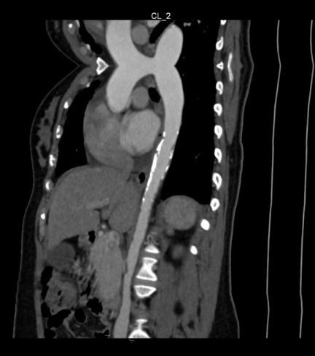

CONCLUSION: The underdiagnosis of TA leads to worse pregnancy and fetal outcome, most likely associated with high rates of Hypertension. TA was identified as an additional differential diagnosis for Hypertension in pregnancy. Clinician awareness of the presentation, diagnosis, and management of TA, as well as a multidisciplinary approach to care for pregnant patients with TA, may result in more favorable outcomes for both mother and baby. Collaboration between vascular specialists, obstetricians, and the patient’s primary care physician enabled us to devise a comprehensive plan to address our patient’s vascular and obstetric conditions and therefore optimize both maternal and fetal outcomes[14].

REFERENCES:

1. Marwah S, Rajput M, Mohindra R, Gaikwad HS, Sharma M, Topden SR. Takayasu's Arteritis in Pregnancy: A Rare Case Report from a Tertiary Care Infirmary in India. Case Rep Obstet Gynecol. 2017;2017:2403451. doi: 10.1155/2017/2403451. Epub 2017 Feb 7. PMID: 28265476; PMCID: PMC5318617.
2. V. C. Wong, R. Y. Wang, and T. Tse, “Pregnancy and Takayasu’s arteritis,” The American Journal of Medicine, vol. 75, no. 4, pp. 597–601, 1983.
3. M. J. Koster, E. L. Matteson, and K. J. Warrington, “Recent advances in the clinical management of giant cell arteritis and Takayasu arteritis,” Current Opinion in Rheumatology, vol. 28, no. 3, pp. 211–217, 2016
4. A. Matsumura, R. Moriwaki, and F. Numano, “Pregnancy in Takayasu arteritis from the view of internal medicine,” Heart and Vessels, vol. 7, no. 1, pp. 120–124, 1992
5. Hauenstein E, Frank H, Bauer JS, Schneider KT, Fischer T. Takayasu's arteritis in pregnancy: review of literature and discussion. J Perinat Med. 2010;38(1):55-62. doi: 10.1515/jpm.2009.120. PMID: 19678743.
6. Assad AP, da Silva TF, Bonfa E, Pereira RM. Maternal and Neonatal Outcomes in 89 Patients with Takayasu Arteritis (TA): Comparison Before and After the TA Diagnosis. J Rheumatol. 2015 Oct;42(10):1861-4. doi: 10.3899/jrheum.150030. Epub 2015 Sep 1. PMID: 26329335.
7. Beilin Y., Bernstein H. Successful epidural anaesthesia for a patient with Takayasu's arteritis presenting for caesarean section. Canadian Journal of Anaesthesia*.*1993;**40**(1):64–66. doi: 10.1007/BF03009321. [[PubMed](https://www.ncbi.nlm.nih.gov/pubmed/8093861)] [[CrossRef](https://dx.doi.org/10.1007%2FBF03009321" \t "_blank)] [[Google Scholar](https://scholar.google.com/scholar_lookup?journal=Canadian+Journal+of+Anaesthesia&title=Successful+epidural+anaesthesia+for+a+patient+with+Takayasu%27s+arteritis+presenting+for+caesarean+section&author=Y.+Beilin&author=H.+Bernstein&volume=40&issue=1&publication_year=1993&pages=64-66&pmid=8093861&doi=10.1007/BF03009321&)]
8. Kathirvel S., Chavan S., Arya V. K., et al. Anesthetic management of patients with Takayasu's arteritis: a case series and review. Anesthesia and Analgesia*.*2001;**93**(1):60–65. [[PubMed](https://www.ncbi.nlm.nih.gov/pubmed/11429340)] [[Google Scholar](https://scholar.google.com/scholar_lookup?journal=Anesthesia+and+Analgesia&title=Anesthetic+management+of+patients+with+Takayasu%27s+arteritis:+a+case+series+and+review&author=S.+Kathirvel&author=S.+Chavan&author=V.+K.+Arya&volume=93&issue=1&publication_year=2001&pages=60-65&pmid=11429340&)]
9. Suri V., Aggarwal N., Keepanasseril A., Chopra S., Vijayvergiya R., Jain S. Pregnancy and Takayasu arteritis: a single centre experience from North India. Journal of Obstetrics and Gynaecology Research*.*2010;**36**(3):519–524. doi: 10.1111/j.1447-0756.2010.01226.x. [[PubMed](https://www.ncbi.nlm.nih.gov/pubmed/20598031)] [[CrossRef](https://dx.doi.org/10.1111%2Fj.1447-0756.2010.01226.x" \t "_blank)] [[Google Scholar](https://scholar.google.com/scholar_lookup?journal=Journal+of+Obstetrics+and+Gynaecology+Research&title=Pregnancy+and+Takayasu+arteritis:+a+single+centre+experience+from+North+India&author=V.+Suri&author=N.+Aggarwal&author=A.+Keepanasseril&author=S.+Chopra&author=R.+Vijayvergiya&volume=36&issue=3&publication_year=2010&pages=519-524&pmid=20598031&doi=10.1111/j.1447-0756.2010.01226.x&)]
10. Hrisrova, D. and Marchev, S.. "Takayasu Arteritis – A Systematic Review" Acta Medica Bulgarica, vol.46, no.3, 2019, pp.56-64. <https://doi.org/10.2478/amb-2019-0033>
11. de Souza AW, de Carvalho JF. Diagnostic and classification criteria of Takayasu arteritis. J Autoimmun. 2014 Feb-Mar;48-49:79-83. doi: 10.1016/j.jaut.2014.01.012. Epub 2014 Jan 21. PMID: 24461381.
12. Singh N., Tyagi S., Tripathi R., Mala Y. M. Maternal and fetal outcomes in pregnant women with Takayasu aortoarteritis: does optimally timed intervention in women with renal artery involvement improve pregnancy outcome? Taiwanese Journal of Obstetrics and Gynecology*.*2015;**54**(5):597–602. doi: 10.1016/j.tjog.2015.08.014. [[PubMed](https://www.ncbi.nlm.nih.gov/pubmed/26522118)] [[CrossRef](https://dx.doi.org/10.1016%2Fj.tjog.2015.08.014" \t "_blank)] [[Google Scholar](https://scholar.google.com/scholar_lookup?journal=Taiwanese+Journal+of+Obstetrics+and+Gynecology&title=Maternal+and+fetal+outcomes+in+pregnant+women+with+Takayasu+aortoarteritis:+does+optimally+timed+intervention+in+women+with+renal+artery+involvement+improve+pregnancy+outcome?&author=N.+Singh&author=S.+Tyagi&author=R.+Tripathi&author=Y.+M.+Mala&volume=54&issue=5&publication_year=2015&pages=597-602&pmid=26522118&doi=10.1016/j.tjog.2015.08.014&)]
13. Suri V., Aggarwal N., Keepanasseril A., Chopra S., Vijayvergiya R., Jain S. Pregnancy and Takayasu arteritis: a single centre experience from North India. Journal of Obstetrics and Gynaecology Research*.*2010;**36**(3):519–524.doi: 10.1111/j.1447-0756.2010.01226.x. [[PubMed](https://www.ncbi.nlm.nih.gov/pubmed/20598031)] [[CrossRef](https://dx.doi.org/10.1111%2Fj.1447-0756.2010.01226.x" \t "_blank)] [[Google Scholar](https://scholar.google.com/scholar_lookup?journal=Journal+of+Obstetrics+and+Gynaecology+Research&title=Pregnancy+and+Takayasu+arteritis:+a+single+centre+experience+from+North+India&author=V.+Suri&author=N.+Aggarwal&author=A.+Keepanasseril&author=S.+Chopra&author=R.+Vijayvergiya&volume=36&issue=3&publication_year=2010&pages=519-524&pmid=20598031&doi=10.1111/j.1447-0756.2010.01226.x&)]
14. Soo-Hoo S, Seong J, Porten BR, Skeik N. Challenges of Takayasu Arteritis in Pregnancy: A Case Report. Vasc Endovascular Surg. 2017 May;51(4):195-198. doi: 10.1177/1538574417698904. Epub 2017 Mar 20. PMID: 28424040.